Exercise 3 – Keys and Entities

The purpose of this exercise is to be able to identify primary keys and to be able to draw simple Entity Relationship Diagrams using MySQL Workbench.

# Background Information

An Entity Relation Diagram shows entities (tables), the attributes of the entities and the relationships between the entities (we will not look at relationships today).

Consider the following two tables of data:

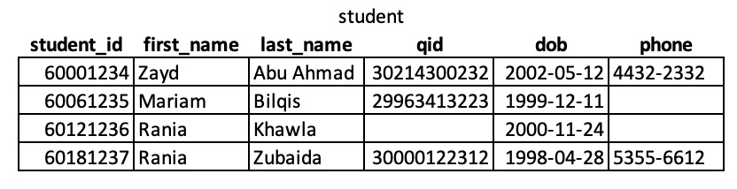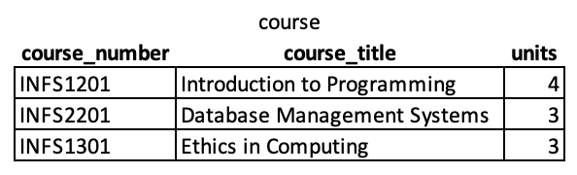

These tables could be representing using the Relational Schema format:

student(**student_id**, first_name, last_name, qid, dob, phone)  
course(**course_number**, name, units)

Alternatively, they could also be shown using ERD (entity relationship diagram) format from MySQL Workbench:

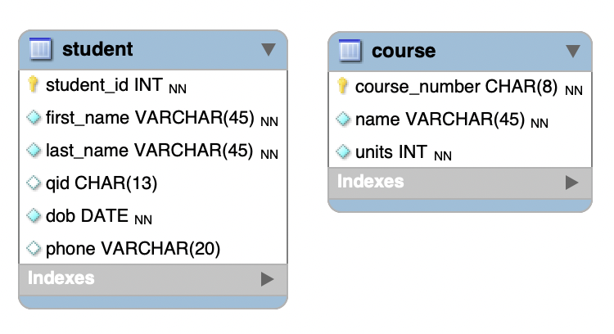

The MySQL workbench tool provides more details and includes which fields are mandatory vs optional as well as the type of data that will be stored. The small NN means not null and will only appear if MySQL Workbench is configured to show the types, you do not need to enable them for this course at the moment.

The small yellow item is a key which is used to indicate a primary key. The blue filled in diamond means that the field must be filled in (i.e. not null) while the open blue diamond means an optional field.

The types shown in the diagram above are:

* INT – integer value
* VARCHAR(30) – a string with up to 30 characters
* DATE – a date in the form YYYY-MM-DD
* CHAR(10) – a string with exactly 10 characters

Remember that each row needs to have something that identifies the row. We call this a primary key.

Movies as a table and Movies as an entity.

Need an introduction to what an entity looks like in a workbench diagram but no relations yet.

# Part A – Completed with the Instructor

In this part, you have been given 4 tables with some sample data. For each table:

1. Write a relational schema description of the table. If no table name is given, try to come up with an appropriate name for the data shown.
2. Create an entity in a MySQL Workbench model (all tables can be placed into the same model even though they are not related). Make sure to identify the attribute(s) for the primary key. Select the NN (not null) for fields which are mandatory.
3. Add a primary key if you think one is missing.

## Table A

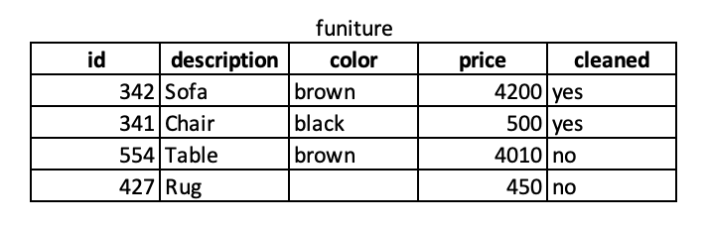

## Table B

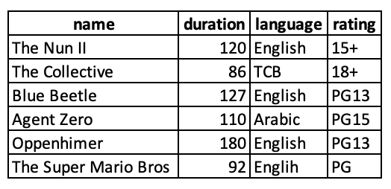

## Table C

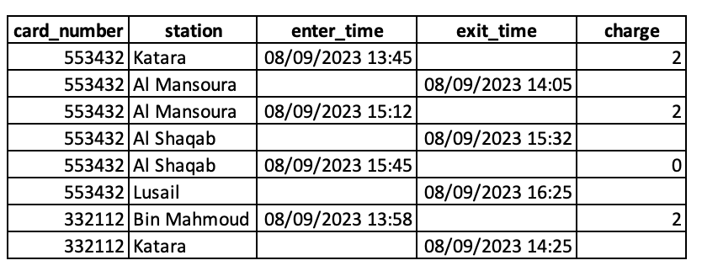

## Table D

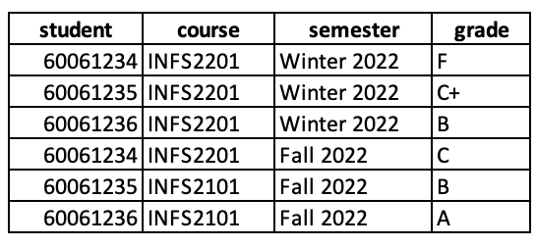

# Part B – Additional Exercises

Complete these exercises in the lab unless there is no time remaining.

Look the entity diagram shown below and create sample tables with at least 10 computers and 4 operating systems. Note that we have a foreign key in this table which is represented by the red diamond (unshaded means it is optional).

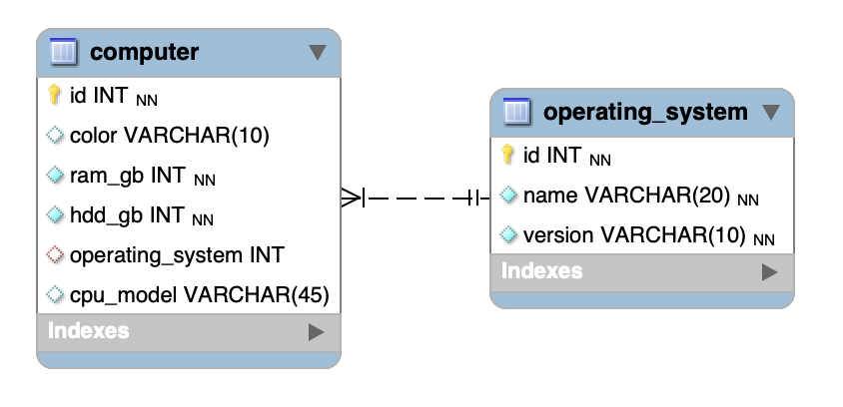

Make the data realistic and do not type gibberish (random letters). You can create the tables in MS Word or in MS Excel.

If an attribute is optional, make sure to include at least one sample with the value missing.